One-to-One

🌟 Definition
# Source: AI Source: Provided by: [Data Path: Persons Table -> ID Column: 1, Name_En Column: Motasem Essam] -> From: [ChatGPT] on [6/10/2026]
A One-to-One (1:1) Relationship exists when one record in Entity A is related to exactly one record in Entity B, and vice versa.
In other words:
One A ↔ One B
Neither side can have more than one matching record.

🎯 Purpose
# Source: AI Source: Provided by: [Data Path: Persons Table -> ID Column: 1, Name_En Column: Motasem Essam] -> From: [ChatGPT] on [6/10/2026]
One-to-One relationships are used when:
- An entity has additional information stored separately.
- Sensitive information needs its own table.
- Data is logically divided into multiple entities.

🧠 Simple Example
# Source: AI Source: Provided by: [Data Path: Persons Table -> ID Column: 1, Name_En Column: Motasem Essam] -> From: [ChatGPT] on [6/10/2026]
Person and Passport
One Person → One Passport
One Passport → One Person

Diagram
Person 1 ───── 1 Passport

Example Data
Person Table
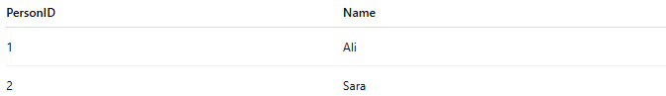
PersonID | Name
1 | Ali
2 | Sara
Passport Table
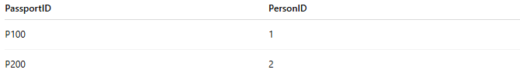
PassportID | PersonID
P100 | 1
P200 | 2
Each person has one passport.
Each passport belongs to one person.

📚 Real-World Examples

1. Person ↔ Passport
# Source: AI Source: Provided by: [Data Path: Persons Table -> ID Column: 1, Name_En Column: Motasem Essam] -> From: [ChatGPT] on [6/10/2026]
Person 1 ───── 1 Passport

2. Employee ↔ Company ID Card
# Source: AI Source: Provided by: [Data Path: Persons Table -> ID Column: 1, Name_En Column: Motasem Essam] -> From: [ChatGPT] on [6/10/2026]
Employee 1 ───── 1 ID Card

3. User ↔ User Profile
# Source: AI Source: Provided by: [Data Path: Persons Table -> ID Column: 1, Name_En Column: Motasem Essam] -> From: [ChatGPT] on [6/10/2026]
User 1 ───── 1 Profile

4. Vehicle ↔ Registration Certificate
# Source: AI Source: Provided by: [Data Path: Persons Table -> ID Column: 1, Name_En Column: Motasem Essam] -> From: [ChatGPT] on [6/10/2026]
Vehicle 1 ───── 1 Registration

📊 ER Diagram Representation
# Source: AI Source: Provided by: [Data Path: Persons Table -> ID Column: 1, Name_En Column: Motasem Essam] -> From: [ChatGPT] on [6/10/2026]
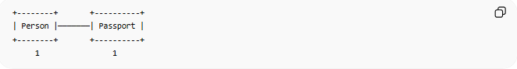
+--------+ +----------+
| Person |───────| Passport |
+--------+ +----------+
1 1
Both sides have cardinality 1.

🗄️ Database Implementation
# Source: AI Source: Provided by: [Data Path: Persons Table -> ID Column: 1, Name_En Column: Motasem Essam] -> From: [ChatGPT] on [6/10/2026]
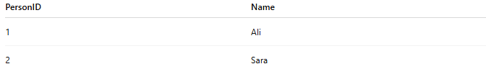
Person Table
PersonID | Name
1 | Ali
2 | Sara

Passport Table
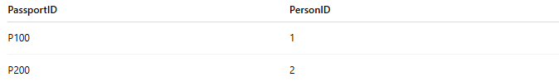
PassportID | PersonID
P100 | 1
P200 | 2

SQL Example
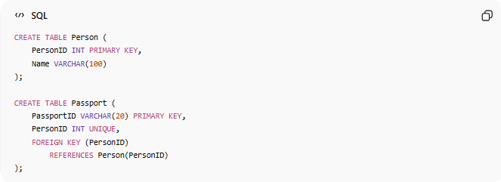
CREATE TABLE Person (
PersonID INT PRIMARY KEY,
Name VARCHAR(100)
);
CREATE TABLE Passport (
PassportID VARCHAR(20) PRIMARY KEY,
PersonID INT UNIQUE,
FOREIGN KEY (PersonID)
REFERENCES Person(PersonID)
);
Notice:
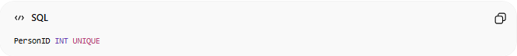
PersonID INT UNIQUE
The UNIQUE constraint ensures one passport per person.

🔢 Characteristics of a One-to-One Relationship
# Source: AI Source: Provided by: [Data Path: Persons Table -> ID Column: 1, Name_En Column: Motasem Essam] -> From: [ChatGPT] on [6/10/2026]
- One record matches one record.
- Both entities have a unique association.
- Often implemented using a UNIQUE foreign key.
- Less common than One-to-Many relationships.

🌍 User Account Example
# Source: AI Source: Provided by: [Data Path: Persons Table -> ID Column: 1, Name_En Column: Motasem Essam] -> From: [ChatGPT] on [6/10/2026]
User Table
UserID | Username
1 | ali123

Profile Table
ProfileID | UserID | Bio
10 | 1 | Web Developer
Relationship:
User 1 ───── 1 Profile
One user has one profile.
One profile belongs to one user.

⚠️ One-to-One vs One-to-Many
# Source: AI Source: Provided by: [Data Path: Persons Table -> ID Column: 1, Name_En Column: Motasem Essam] -> From: [ChatGPT] on [6/10/2026]
One-to-One
Person 1 ───── 1 Passport
Only one match on each side.

One-to-Many
Customer 1 ───── N Orders
One customer can have many orders.

Comparison
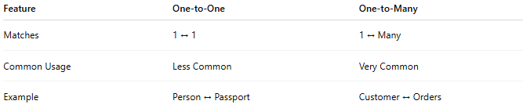
Feature | One-to-One | One-to-Many
Matches | 1 ↔ 1 | 1 ↔ Many
Common Usage | Less Common | Very Common
Example | Person ↔ Passport | Customer ↔ Orders

🧠 Simple Analogy
# Source: AI Source: Provided by: [Data Path: Persons Table -> ID Column: 1, Name_En Column: Motasem Essam] -> From: [ChatGPT] on [6/10/2026]
Think of a person and their national passport:
Ali ↔ Passport A123456
Ali cannot have two active passports in this example, and Passport A123456 belongs only to Ali.
This is a One-to-One Relationship.

🧭 Summary
# Source: AI Source: Provided by: [Data Path: Persons Table -> ID Column: 1, Name_En Column: Motasem Essam] -> From: [ChatGPT] on [6/10/2026]
A One-to-One (1:1) Relationship occurs when one record in one entity is associated with exactly one record in another entity, and vice versa. Examples include Person–Passport, User–Profile, and Employee–ID Card. It is typically implemented using a foreign key with a UNIQUE constraint.

